

CS 2103

Assignment in Data Structures (First Meeting Assignment)

Submitted by:

**Robert Michael Lim, BSCS – 2**

Submitted to:

**Ms. Christine F. Peña**

What I know about my operators in C:

**Arithmetic Operators**

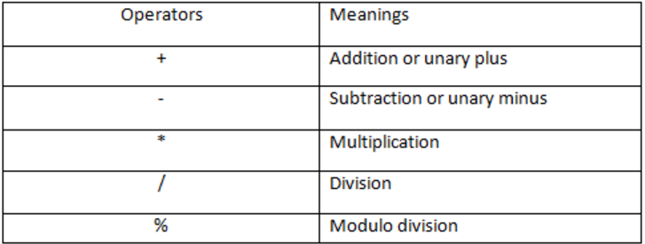

**Relational Operators**

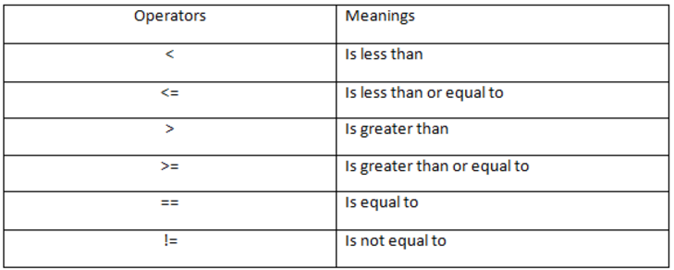

**Logical Operators**

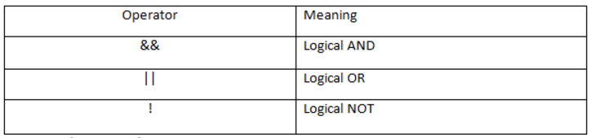

**Assignment Operator** ( = )

Increment and decrement operators (++, --), can be used for prefix and postfix (++x, --;x++, x--)

**Ternary operator** ?: *(/*condition here*/)****?*** */*true*/* ***:*** */*false*/*

**Bitwise Operators**

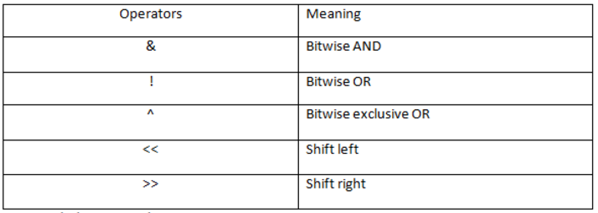

What I do not know:

**Order of precedence:**

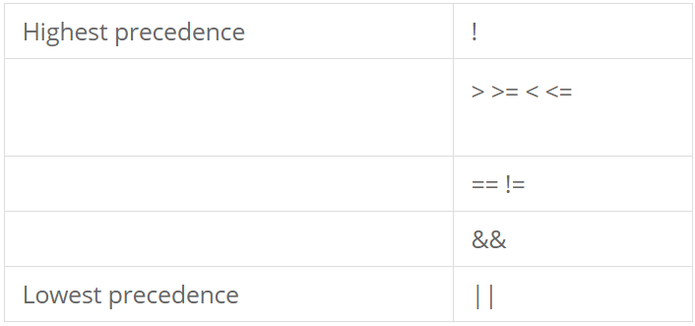

**Precedence of operators:**

